R. Reports Menu: 5. Depreciation Report

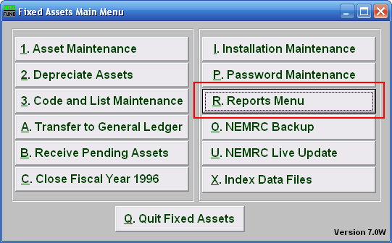
Click on “R. Reports Menu” from the Main Menu and the following window will appear:

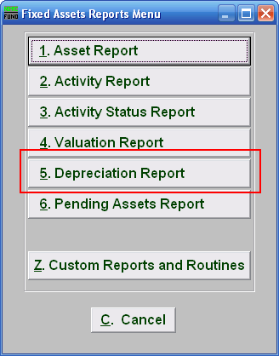
Click on “5. Depreciation Report” from the Reports Menu and the following window will appear:
Depreciation Report
Data ranges and grouping

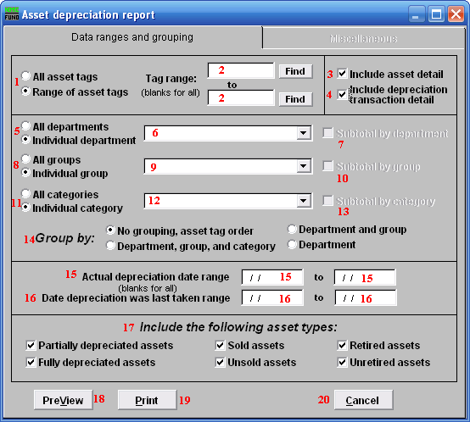
- All asset tags OR Range of asset tags: Select whether you want the report to be for All asset tags or a Range of asset tags.

- Tag range: If you chose Range of asset tags, this field will become available for you to enter the Asset tag or you can click on the “Find” button and select from the drop down menu, then select where you want the report to end with or click on the “Find” button. OR leave blank for all.

- Include asset detail: Click on this box is you want the report to include asset detail.

- Include depreciation Transaction detail: Click on this box if you want the report to include depreciation transaction detail.

- All departments OR Individual department: Select whether you want the report to be for All departments or an Individual department.
- Selector: If you chose Individual department, click on the drop down arrow and select from the table.

- Subtotal by department: If you chose 5 All departments, AND you click on 14 Group by: Department, Department and group OR Department, group and category, this option becomes available to you. Click on this to Subtotal by department.

- All groups OR Individual group: Select whether you want the report to be for All groups or an Individual group.

- Selector: If you chose Individual group, click on the drop down arrow and select from the table.

- Subtotal by group: If you chose 8 All groups, AND you click on 14 Group by: Department, Department and group OR Department, group and category, this option becomes available to you. Click on this to Subtotal by group.

- All categories OR Individual categories: Select whether you want the report to be for All categories or an Individual category.

- Selector: If you chose Individual category, click on the drop down arrow and select from the table.

- Subtotal by category: If you chose 11 All categories, AND you click on 14 Group by: Department, Department and group OR Department, group and category, this option becomes available to you. Click on this to Subtotal by category.

- Group by: Select how you would like the report to group the assets by.

- Actual depreciation date range: Enter the date you wish for the report to start with to the date you wish for the report to end with, OR leave blank to include all dates.

- Date depreciation was last taken range: Enter the date you wish for the report to start with to the date you wish for the report to end with, OR leave blank to include all dates.

- Include the following asset types: Select the type of assets you would the report to include.

- PreView: Click this button to preview. Refer to GENERAL PREVIEW for more information.

- Print: Click this button to print. Refer to GENERAL PRINTING for more information.

- Cancel: Click “Cancel” to cancel and return to the previous screen.

Miscellaneous
Click on the “Miscellaneous” tab and the following window will appear:

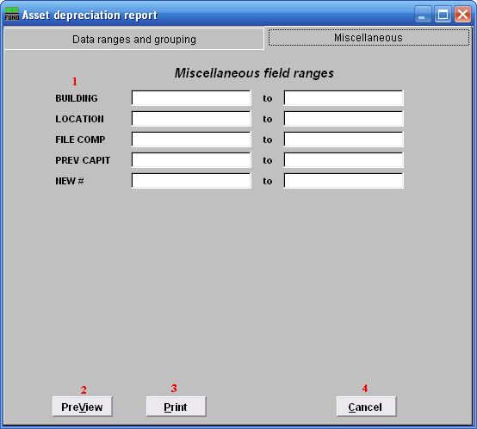
- Miscellaneous field ranges: These fields are user defined in “I. Installation” off the Main Menu.

- PreView: Click this button to preview. Refer to GENERAL PREVIEW for more information.

- Print: Click this button to print. Refer to GENERAL PRINTING for more information.

- Cancel: Click “Cancel” to cancel and return to the previous screen.

